Unparalleled Performance

[Watch Video](https://www.kingston.com/en/video/play?videoId=WnoT02uVTFvrkClms38HG6tYbMCtC7wafPo406DHxZ7LGb2ZPJj9J4XcY1miyX_pPv3Dhg3wSCCrU14dt7SmAA2&start=0&autoPlay=False&chromeless=False&captionOption=No)

DTMAX

* [Intro](https://www.kingston.com/en/usb-flash-drives/datatraveler-max#product-features)
* [Key Features](https://www.kingston.com/en/usb-flash-drives/datatraveler-max#key-feature)
* [Specifications](https://www.kingston.com/en/usb-flash-drives/datatraveler-max#specifications)
* [Resources](https://www.kingston.com/en/usb-flash-drives/datatraveler-max#links)
* [Datasheet](https://www.kingston.com/datasheets/dtmaxa_us.pdf)

[**Buy**](https://www.kingston.com/en/usb-flash-drives/datatraveler-max#atc)

DataTraveler Max USB 3.2 Gen 2 Series Flash DriveAvailable in USB-C® or USB-A

Kingston’s DataTraveler® Max series USB flash drives leverage the latest USB 3.2 Gen 2 standard to deliver record-breaking read/write speeds up to 1,000/900MB/s1. Designed with portability and convenience in mind, the unique ridged casing protects the connector when not in use and is easily moved with a single motion. Available in USB Type-C®2 and Type-A connections to support next-gen and traditional laptops and desktops. The DT Max series delivers premium performance and expanded capacities up to 1TB3 making them the ideal solution for transferring and storing large digital files such as HD photos, 4K/8K videos, music and more.

Both the Type-C and Type-A connector varieties in the DT Max series are backed by a limited five-year warranty, free technical support and legendary Kingston reliability.

* Advanced USB 3.2 Gen 2 Drives
* Unique ridged casing with keyring loop
* Up to 1,000MB/s1 read speeds
* Capacities up to 1TB3

Key Features



Latest USB 3.2 Gen 2 Standard

Move your files in a flash with incredible speeds up to 1,000MB/s Read, 900MB/s Write1.

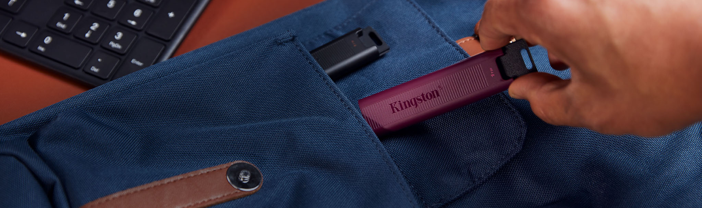

Uncompromised Storage

Available in a range of high capacities from 256GB-1TB3 to carry your digital library on the go.



Dual Option for Connectivity

USB Type-C® and Type-A connector varieties to support next-gen and traditional laptops or desktops for seamless file transfers.



Unique Design

Convenient one-handed sliding cap, LED status indicator, and functional keyring loop.

Awards and Reviews

This drive copied the entire camera folder from my Pixel phone to my laptop so quickly I feared it must have failed. But when I checked my laptop, everything was present and correct.

[Read Full Review](https://www.wired.com/gallery/best-usb-flash-drives/)

...if your devices have only USB-C ports and you don’t want to bother with a dongle, this flash drive provides plenty of speed and storage for general use.

[Read Full Review](https://www.nytimes.com/wirecutter/reviews/the-best-usb-3-0-thumb-drive/)The Best USB Flash Drives

It’s by far the speediest drive I have tested (1,000 MB/s read, 900 MB/s write), so it’s especially perfect for transferring large files.

[Read Full Review](https://www.wired.com/gallery/best-usb-flash-drives/)

It’s a great choice if you want to back up or move files between smartphones, tablets, or laptops with USB-C ports.

[Read Full Review](https://www.wired.com/gallery/best-usb-flash-drives/)

The DataTraveler Max can run with and even beat a whole host of portable NVMe SSDs, as demonstrated with an exclamation point by our 100GB transfer test. Best-in-class and TweakTown Elite.

[Read Full Review](https://www.tweaktown.com/reviews/9929/kingston-datatraveler-max-1tb-usb-worlds-fastest-pen-drive/index.html)Kingston DataTraveler Max 1TB USB-C Review - World's Fastest Pen Drive

We have literally every SSD that matters ever made at our disposal, but this little USB drive has captured our hearts. It is, in our opinion, the best overall execution of fast, portable storage we've seen to date. There is nothing like it.

[Read Full Review](https://www.tweaktown.com/reviews/9929/kingston-datatraveler-max-1tb-usb-worlds-fastest-pen-drive/index.html)Kingston DataTraveler Max 1TB USB-C Review - World's Fastest Pen Drive

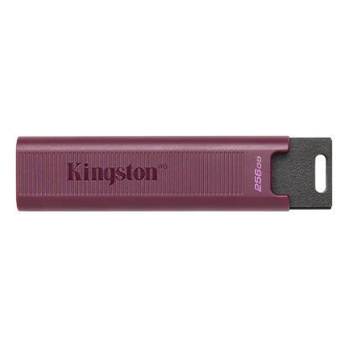

* [DataTraveler Max A DTMAXA/256GB](javascript:void(0))
* [DataTraveler Max A DTMAXA/256GB](javascript:void(0))
* [DataTraveler Max A DTMAXA/256GB](javascript:void(0))

Capacity

 256GB

 512GB

 1TB

Connector

 USB-A

 USB-C

* Part Number: DTMAXA/256GB
* USB 3.2 Gen 2
* 256GB, 512GB, 1TB
* Up to 1,000MB/s Read, 900MB/s Write

[**Where to Buy**](https://www.kingston.com/en/wheretobuy)